Department of Technology Information, State Polytechnic of Malang

# Jobsheet-15:Web Hosting

**Design and Programming Web Courses** Design and Programming Web Team Teaching *December 2020*

**Topics**

* Understanding Web Hosting
* Static Website Hosting
* Dynamic Website Hosting

**Aims**

Students are expected to be able to:

1. Understand the concept of Web Hosting
2. Knowing the application of the concept of Web Hosting to the website

**preliminary**

**Understanding Web Hosting** *Web Hosting*is the process of renting or buying space to host a website on the World Wide Web (WWW). Website content such as HTML, CSS and images is placed on the server for online viewing.Hosting provider allocates space for the website on the server to store its files.

Every website we ever visit is hosted on a server. A server is a computer that connects other web users to a site from anywhere in the world. The web hosting service provider has servers, connectivity, and services related to web hosting.

**How Web Hosting Works** Web hosting is done by uploading the files that make up the website from a local computer to a web server. Server resources (RAM, hard drive space, and bandwidth) are allocated to websites that use them. The share of server resources varies depending on the type of hosting package chosen.

* Shared Hosting

A website is hosted on the same server as any other website. Most of the web hosting companies provide shared hosting because it is cheaper and easier. Shared hosting is suitable for new sites that don't expect a lot of traffic in the short term, such as personal websites and those of small and medium-sized businesses.

* Virtual Private Server (VPS)

VPS is one level above shared hosting, widely used for medium sized businesses. With a VPS, users are isolated from each other. A virtual server appears to each user as a dedicated server even though it actually serves multiple websites. Users can make changes (customization) and manage their own servers.

* Dedicated server

Dedicated servers (dedicated servers) provide the entire server for rent. This type of hosting is relatively expensive when compared to shared hosting so it is only used when your website has a lot of traffic or when more server control is required.

* Cloud hosting

Cloud hosting is the newest type of hosting to enter the market, and has become very popular in recent years. This type of hosting operates on many interconnected web servers that provide an affordable, scalable and reliable web infrastructure. Cloud hosting plans typically offer unmeasured and reliable bandwidth as well as an unlimited amount of disk space for unlimited domains which explains why so many big businesses are turning to the cloud. This is an effective method for running websites with resource intensive applications or large amounts of content assets such as images, but the costs can be much higher.

**Github Pages** GitHub is a website-based application with a Version Control System (VCS) which provides services to store repositories for free. Respository is a folder that can be used to store source code. With GitHub we can collaborate on a specific project so that we can continue to make regular updates, including tracking and saving changes that occur in the project.

In simpler terms, some of the functions of GitHub include:

1. Can be used to store the repository.
2. Become a container or tool for collaboration and working on a project.
3. Load your profile so you can follow other programmers in this app.
4. Able to monitor certain repositories.

Github Pages is a Github service that provides free publications for websites. Github Pages can publish websites from user repositories. But Github Pages can only accept static pages (html, css, and javascript).

# Practicum Part 1. Static Web Hosting Using Github Pages

We can host static websites using github pages. Here are the steps:

|  |  |
| --- | --- |
| **Step** | **Explanation** |
| 1 | Create a GitHub account at <https://github.com/join> |
| 2 | Download Git desktop on <https://git-scm.com/downloads>according to the operating system used, then do the installation. |
| 3 | After finishing the installation, create a new repository in the GitHub application. This repository will contain the project folder that we will be hosting.  Select the New button. |

|  |  |
| --- | --- |
|  |  |
| 4 | Give the repository name username.github.io (the username section matches your username), this naming is a naming format in accordance with the hosting terms on Github. After that click "Create repository" |
| 5 | Next, we will upload the static website files that we have into the github repository. Right  click on the folder to be hosted, select "Git Bash Here". |

|  |  |
| --- | --- |
|  | Next, we will initialize the folder so that it becomes a git repository and push the file to the repository on github. Write down one by one the command below.  git init git add -A  git commit -m "first commit" git branch -M main  git remote add origin https://github.com/wildais/wildais.github.io.git git push -u origin main |
| 6 | Then open the browser username.github.io. Then the static website file that is hosted will appear. Take a screenshot and write your username.github.io link (question number 1) |

# Practicum Part 2. Static Web Hosting Using Github Pages

In this section, we will do web hosting on a free hosting provider. Follow these steps to host a dynamic website:

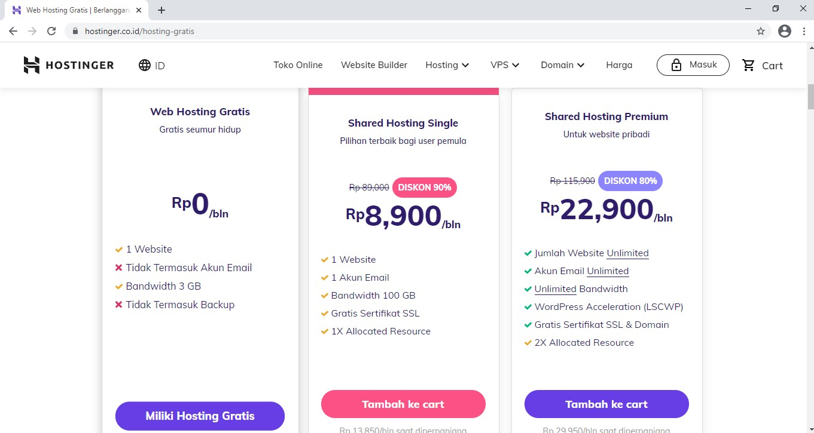

|  |  |
| --- | --- |
| **Step** | **Explanation** |
| 1 | We'll be using a free hosting provider, Hostinger. Open web hostinger via  [https://www.hostinger.co.id/free-domain](https://www.hostinger.co.id/domain-gratis) |
| 2 | Select free web hosting by clicking the "Have Free Hosting" button |
| 3 | Register by entering your email and password. We can also go directly to your Facebook or Google account. |
| 4 | After that, we can learn by reading some of the material provided, or we can directly choose to do web hosting. |

|  |  |
| --- | --- |
| 5 | Next, we will upload the project we have, first name the website and create a password with at least 12 characters consisting of uppercase, lowercase, numbers and characters. |
| 6 | Because the project we will be hosting is a project that has been made before, then select "Upload your site" to upload the files we have. |
| 7 | Then we will go to the page <https://files.000webhost.com/> Upload the files we have in the public_html folder |
| 8 | Then open it again <https://www.000webhost.com/members/website/list>  Open the website that we have and press the "Manage Website" button |

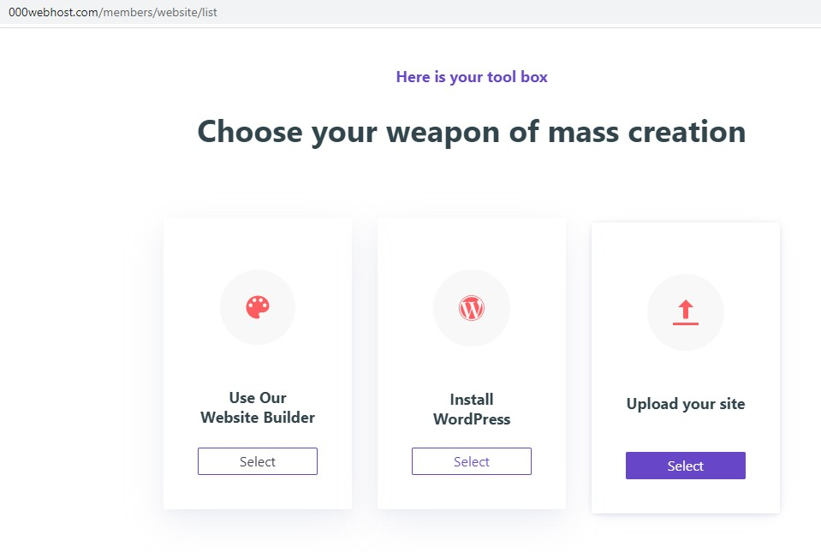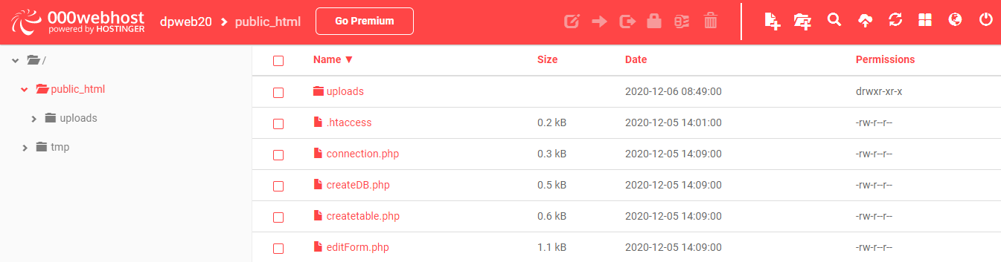

|  |  |
| --- | --- |
|  |  |
| 9 | After the Dashboard opens, on the side bar select Tools→ Database Manager. Create a new database. |
| 10 | Then open PhpMyAdmin.    From the database that has been created, import the .sql file according to the database used in the uploaded project (First, export the .sql file from the database on localhost) |

|  |  |
| --- | --- |
|  |  |
| 11 | Next, edit the connection.php file that was uploaded by changing the username, password, and database name according to what was created in the database manager. |
| 12 | Open the web that has been hosted via <https://websitename.000webhostapp.com/> websitename is filled in according to the name of your respective website.  Screenshot how it looks and write your <https://websitename.000webhostapp.com/> link (question number 2) |

# Reference:

1. htt[ps://www.nameche](http://www.namecheap.com/hosting/what-is-web-hosting-definition/)a[p.com/hosting/what-is-web-hosting-definition/](http://www.namecheap.com/hosting/what-is-web-hosting-definition/)
2. https://pages.github.com